WAP PILOT
WHATSAPP AUTOMATION & COMMERCIAL CRM PLATFORM
PRODUCT: WAP PILOT Enterprise SaaS (Meta WhatsApp Cloud API Certified)
CONTACT NAME: Kiruba Varshini
DESIGNATION: WAP PILOT Product Manager
WHATSAPP / PHONE: +91 86109 35770
OFFICIAL EMAIL: kirubavarshini54@gmail.com
ADMIN PORTAL LINK: https://admin.wapppilot.com / https://dhigrowth-crm.vercel.app/

WAP PILOT bridges the gap between modern businesses and their customers by delivering a unified, autonomous WhatsApp Business infrastructure. Built on the official Meta WhatsApp Cloud API v20.0, WAP PILOT empowers enterprises, real estate firms, educational institutions, clinics, and e-commerce companies with multi-tenant workspace isolation, 24/7 autonomous AI concierges, official Meta template approval workflows, automated invoicing with PDF due collection, and bulk broadcast messaging.
1. Executive Dashboard: Omnichannel Business Command Center
The Executive Dashboard provides management with a real-time, comprehensive view of communication performance, active automations, contact growth, and revenue collection.
- Live Meta Channel Status: Displays real-time WhatsApp Cloud API webhook connectivity, verified phone numbers, and encrypted channel health.
- Key Operational Metrics: Total CRM Leads captured, active automated workflow bots, official WhatsApp messages delivered, read rates, and collection balance.
- Quick Action Toolbar: 1-click shortcuts to Add Customer/Lead, Schedule Broadcast Campaign, Create Meta Template, and Top-Up AI Credits.
- Multi-Workspace Selector: Enables seamless switching between isolated company workspaces and client tenant partitions.
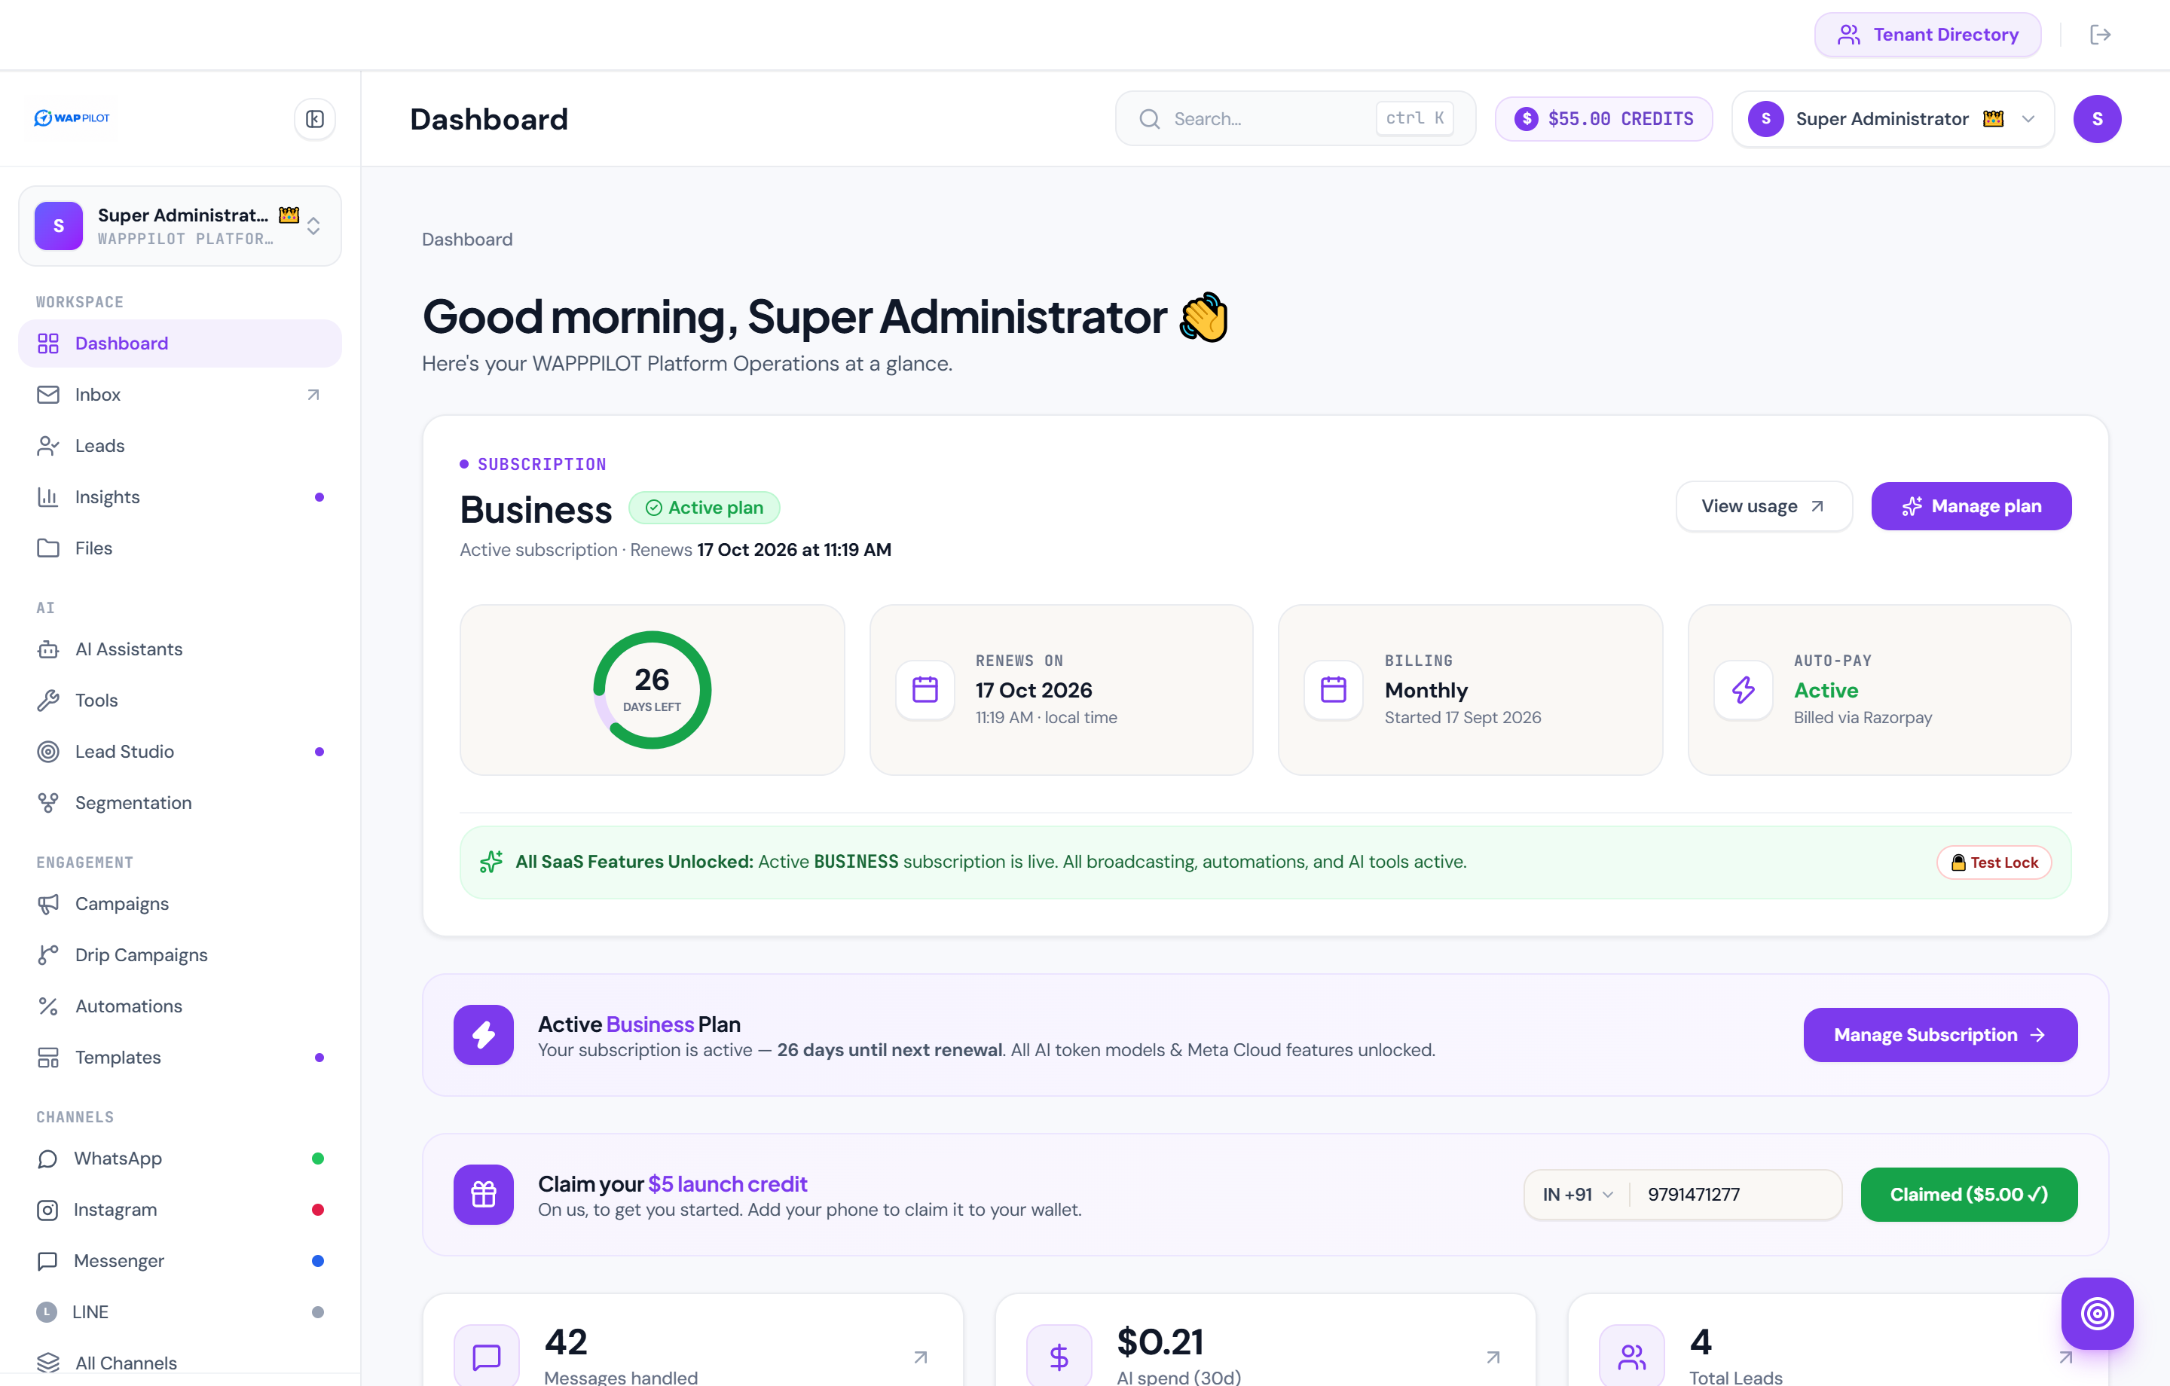
2. Team Inbox & WhatsApp Live Chat: Two-Way Customer Hub
A collaborative, enterprise-grade inbox designed for customer support teams and sales agents, featuring real-time speech bubbles, rich media support, and AI coexistence.
- Two-Way Real-Time Messaging: Instant synchronization with Meta WhatsApp Cloud API webhooks with live delivered and read checkmarks.
- AI Auto-Pilot vs Human Agent Toggle: One-click switch per conversation allowing agents to step in manually or hand off the chat to the autonomous AI Concierge.
- Rich Media Attachments: Full support for sending and receiving public images, PDF brochures, invoices, audio notes, and catalog cards.
- Customer Context Sidebar: Instant access to customer name, phone number, city, tags, assigned deal value, internal team notes, and conversation timestamps.
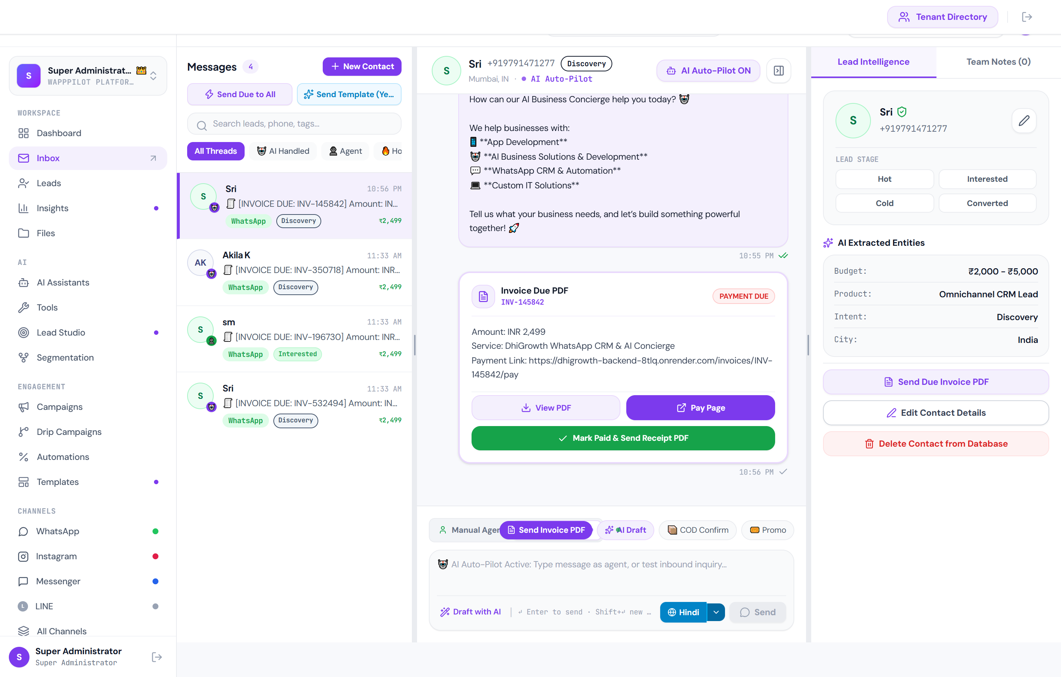
3. Message Templates & Official Meta Approval Workflow
WAP PILOT eliminates the hassle of WhatsApp template compliance by directly integrating with the Meta Graph API v20.0 for instant creation, dynamic token formatting, and official approval.
- Official Meta Cloud API Formatting: Templates are automatically structured into Meta components: Header (Image/Text), Body with variables, Footer, and Quick Reply / Call-To-Action buttons.
- Live Approval Status Tracking: Real-time query of Meta Graph API showing APPROVED (green badge), PENDING REVIEW (amber clock), or REJECTED (red badge).
- Meta Compliance Notice Engine: Displays exact rejection reasons provided by Meta compliance guidelines directly on the template card for rapid adjustment.
- Dynamic Variable Placeholders: Quick-insert buttons for + {{1}} Customer Name, + {{2}} Custom Param (City/Tariff), and + {{3}} Links/Offers.
- Direct Meta Graph API Submission: 1-click submission sends templates straight to Meta's review servers without needing to access Meta Business Manager manually.
- Interactive Keyword Trigger Simulator: Type any customer test phrase (e.g., 'hi', 'price', 'app demo') to test which auto-reply template dispatches in real-time.
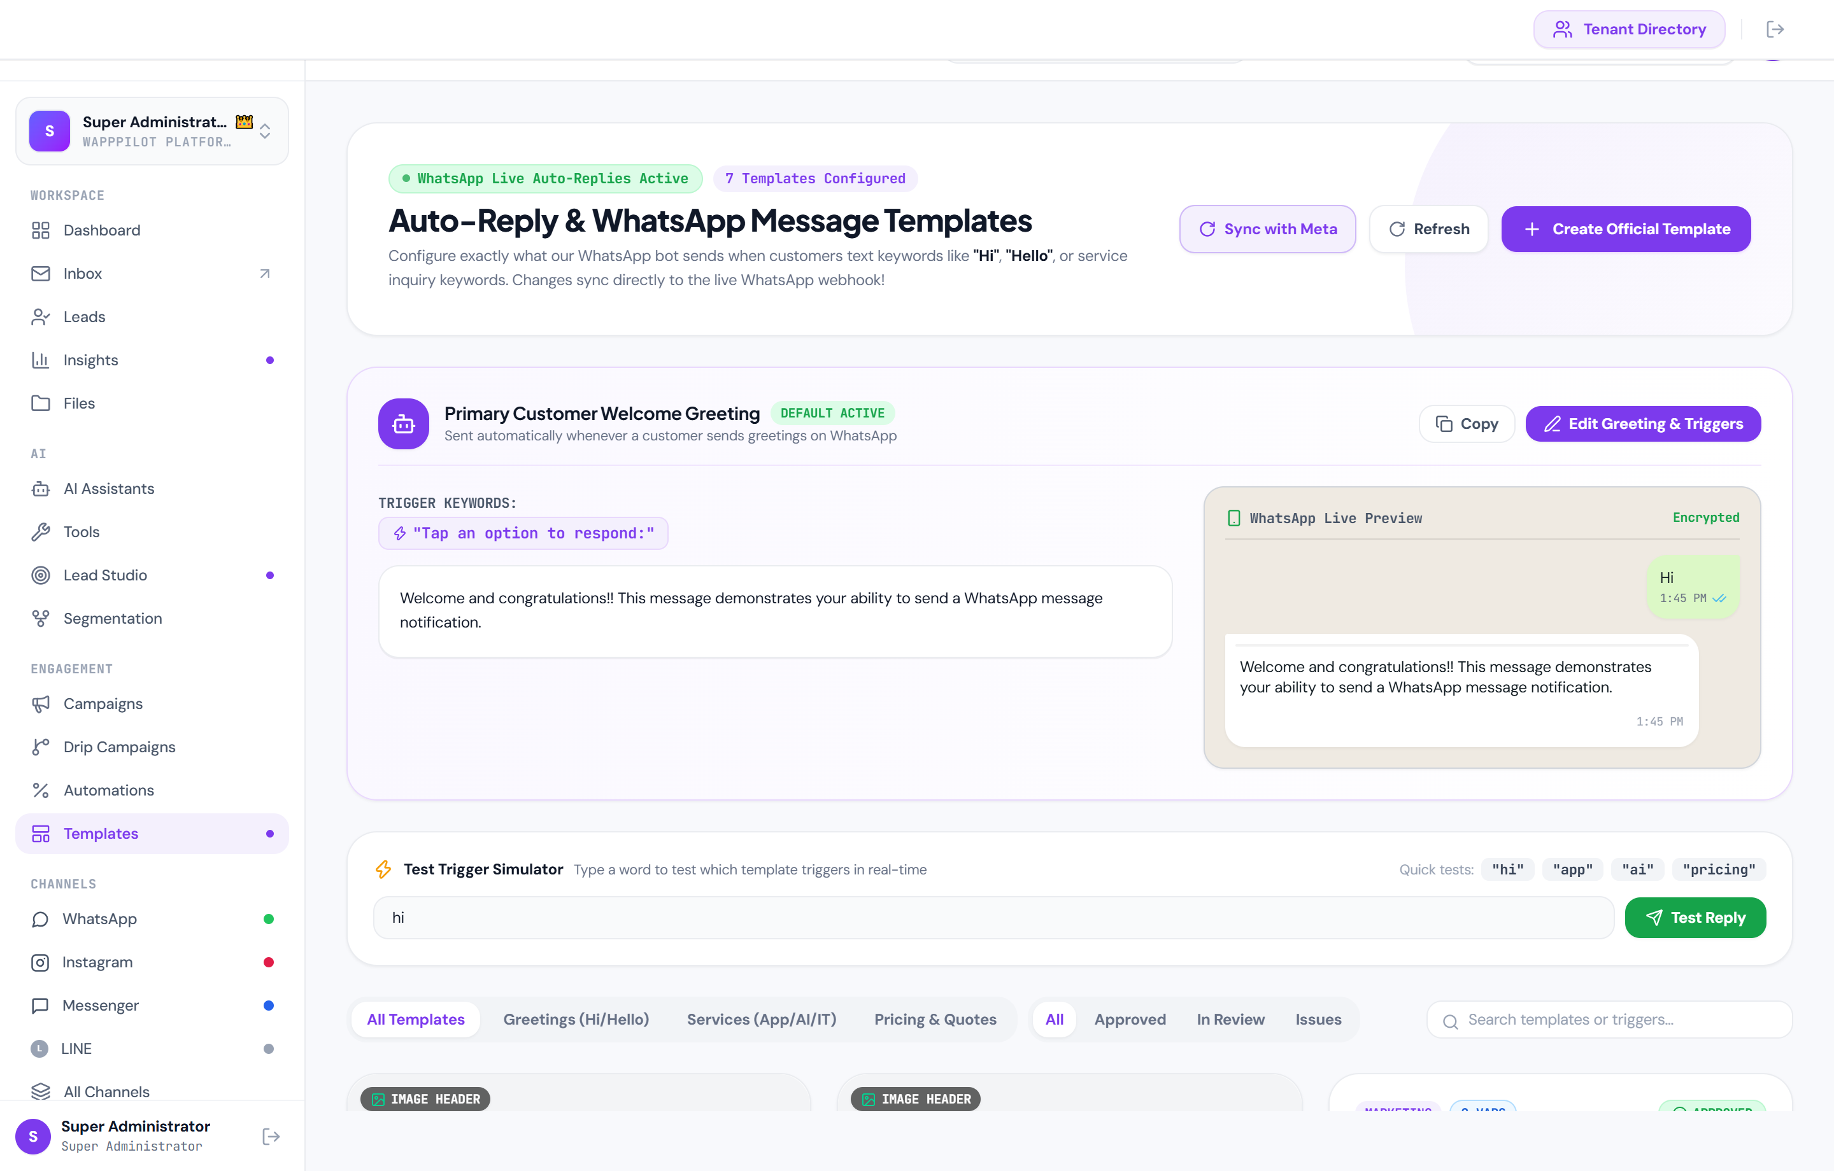
4. Visual Template Editor with Realistic WhatsApp Mobile Preview
A visual builder designed for business owners to draft compliant message templates with instant preview of how customers view the message on their phones.
- Realistic WhatsApp Bubble Preview: Interactive preview accurately renders image banners, bold text markdown (*bold*), and variable substitutions.
- Curated Media Banner Presets: Instant selection of high-converting header banners for Tech, AI, Real Estate, E-Commerce, and Offers.
- Official Approval Toggle: Optionally submits templates directly to Meta Cloud API for review immediately upon clicking Save.
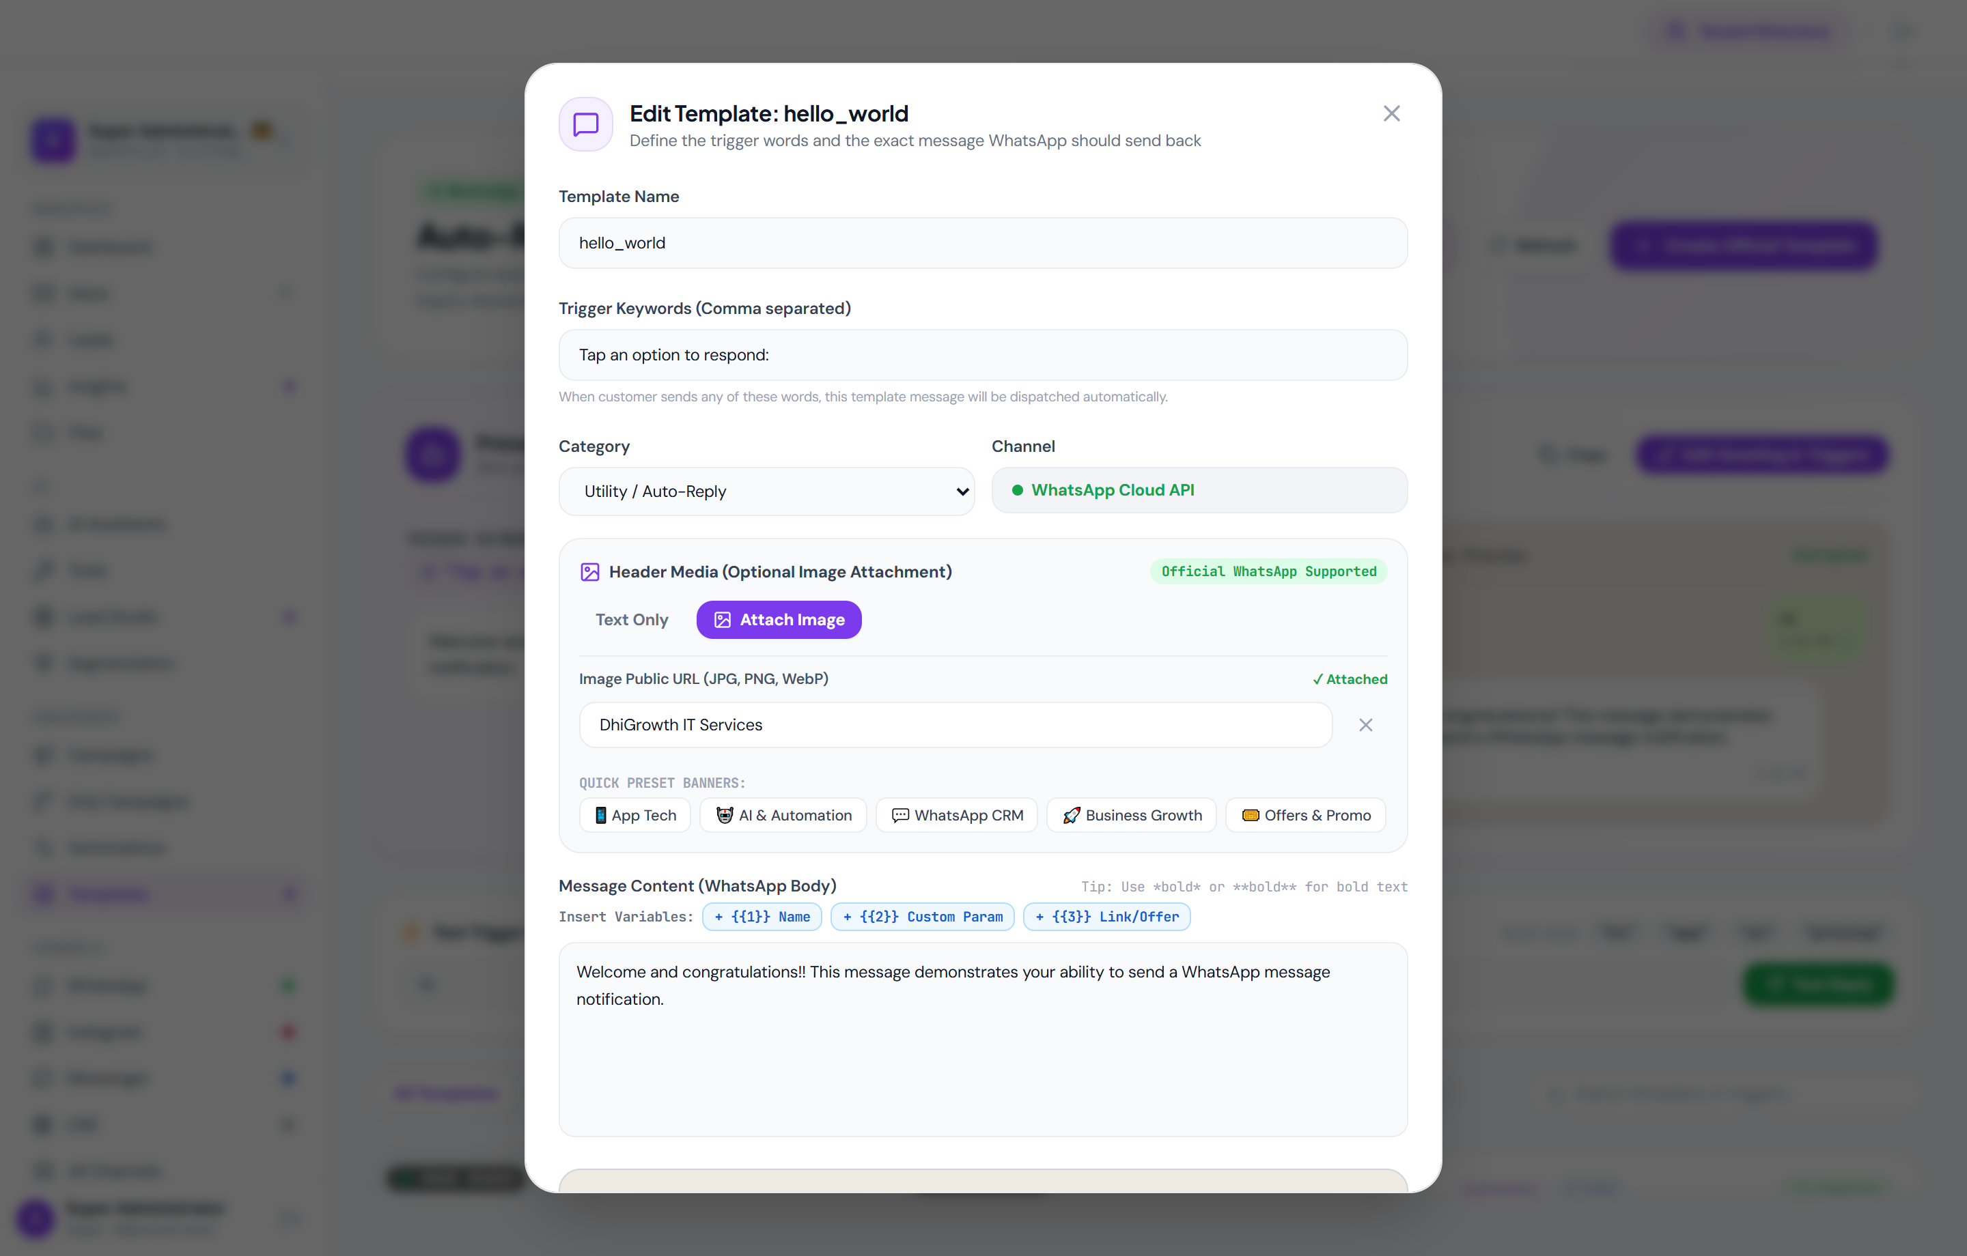
5. Workflow Automations & Intelligent Keyword Auto-Responder
Automate repetitive business workflows and guide leads toward conversion with zero manual intervention.
- Keyword Match Triggers: Detects incoming trigger phrases such as 'order', 'quote', 'demo', 'pricing', 'support' in customer chats.
- Multi-Step Automated Actions: Automatically sends interactive catalogs, dispatches approved templates, updates customer tags, or routes to human agents.
- Active / Paused Controls: One-click toggles to activate or pause specific automated campaigns on the fly.
- Test Trigger Runner: Simulate inbound keyword executions directly from the management console to verify bot response workflows.
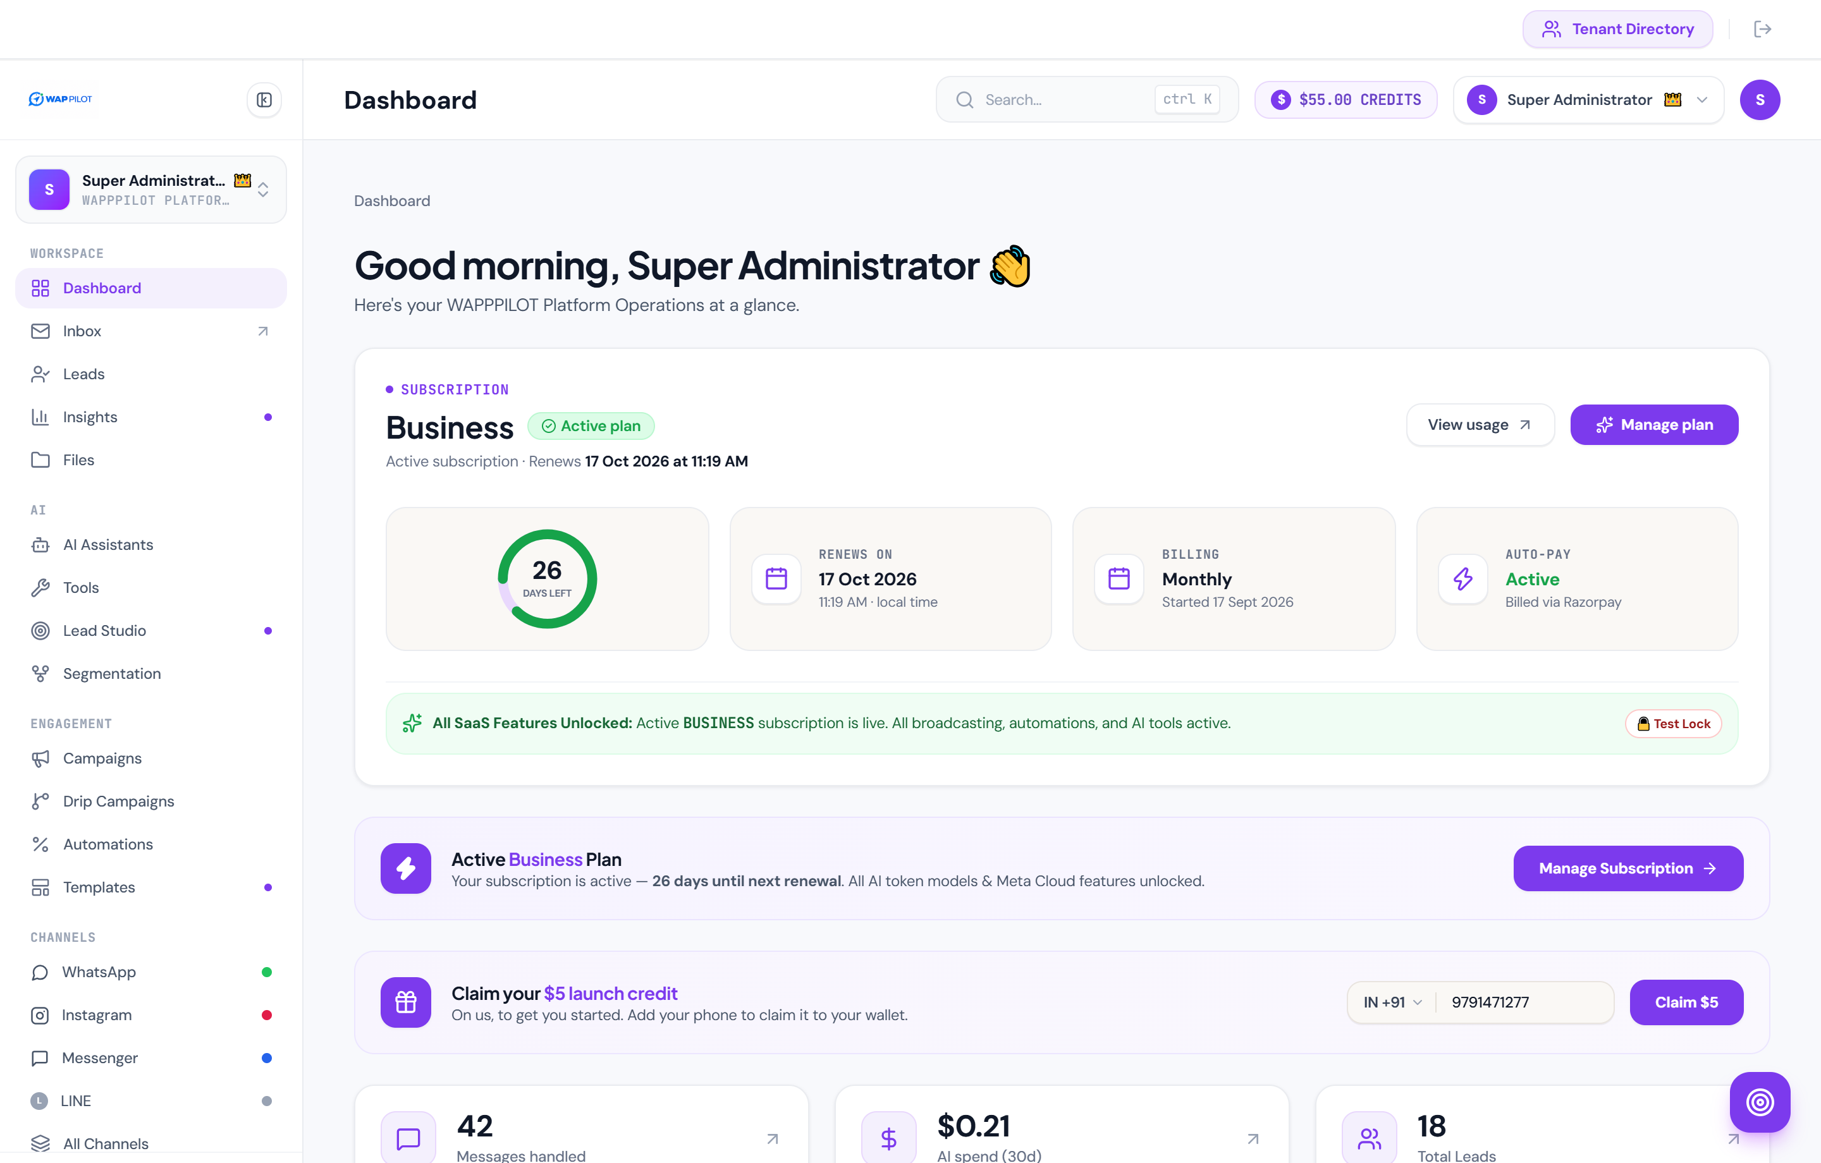
6. Campaigns & WhatsApp Bulk Broadcast Manager
Launch targeted, high-engagement WhatsApp broadcast marketing campaigns with industry-leading 98% open rates and verifiable ROI.
- Segment-Based Broadcasts: Target specific audience segments (e.g. Hot Leads, Overdue Rent Tenants, New Enquiries) with personalized variables.
- Full Lifecycle Delivery Analytics: Real-time tracking of Total Sent, Delivered, Read, Replied, Conversions, Revenue Generated, and ROAS.
- Interactive Response Buttons: Equip broadcasts with quick-reply buttons ('Yes, Interested', 'Schedule Call', 'Pay Now') to drive immediate lead response.
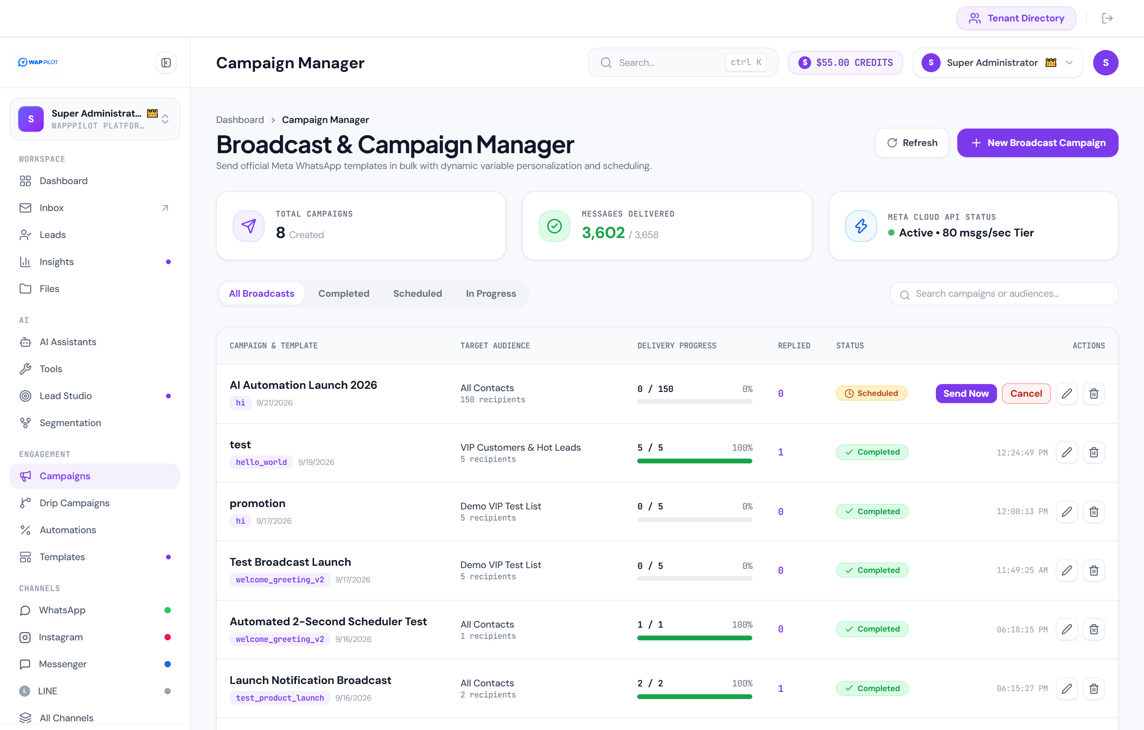
7. Contacts & Lead Management: Integrated Omnichannel CRM
A centralized directory organizing every customer contact, enquiry, and conversation history across all channels.
- Comprehensive Contact Cards: Full Name, Phone Number, Email, City, Current Deal Value, and Lifetime Activity timestamps.
- Color-Coded Lead Stage Tags: Categorize contacts as Hot Lead, Interested, Closed Won, Follow Up, or Inactive.
- Fast Search & Multi-Tag Filters: Quickly isolate specific customer cohorts for follow-ups or bulk campaigns.
- Bulk CSV Import & Manual Lead Creation: Effortlessly import existing customer databases or add new prospective clients in seconds.
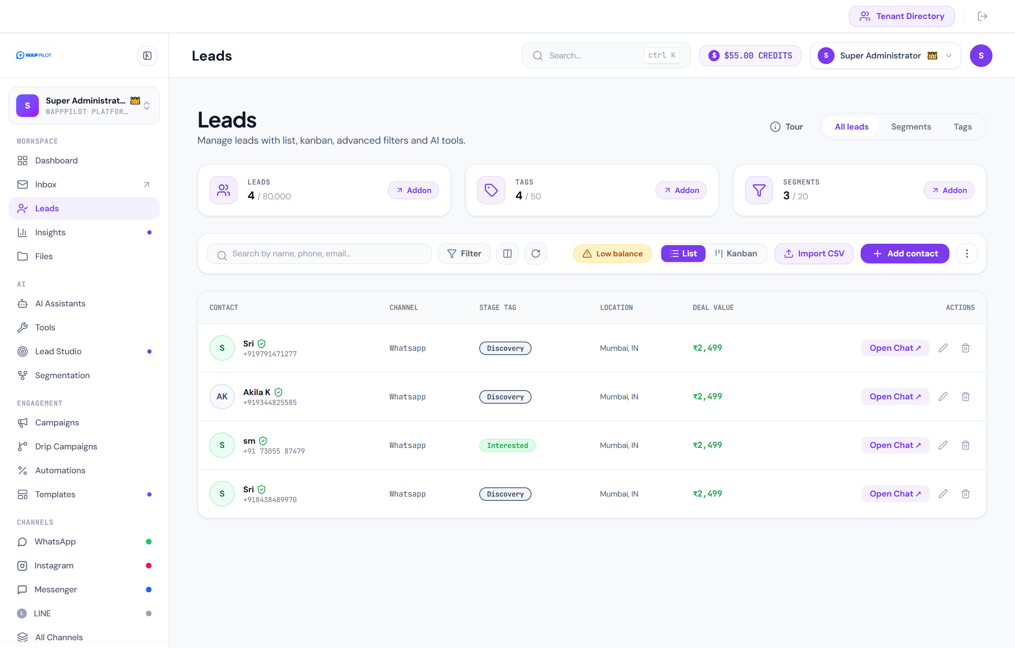
8. Invoicing & WhatsApp Payment Due Collection Engine
Eliminate delayed payments and manual follow-ups by generating and sending professional PDF invoices directly into customer WhatsApp chats.
- Automated PDF Invoice Generator: Creates branded, itemized PDF tax invoices with item breakdowns, customer details, and total due.
- 1-Click WhatsApp Payment Due Broadcast: Dispatches overdue or upcoming payment reminders with the official PDF bill attached directly to WhatsApp.
- Payment Status Tracking: Live classification of customer invoices as PAID, DUE, or OVERDUE.
- Razorpay & Stripe Checkout Integration: Embedded payment links allowing customers to pay instantly via UPI, Cards, NetBanking, or Digital Wallets.
- Automatic Status Reconciliation: Mark payments as settled manually or automatically via payment gateway webhook callbacks.
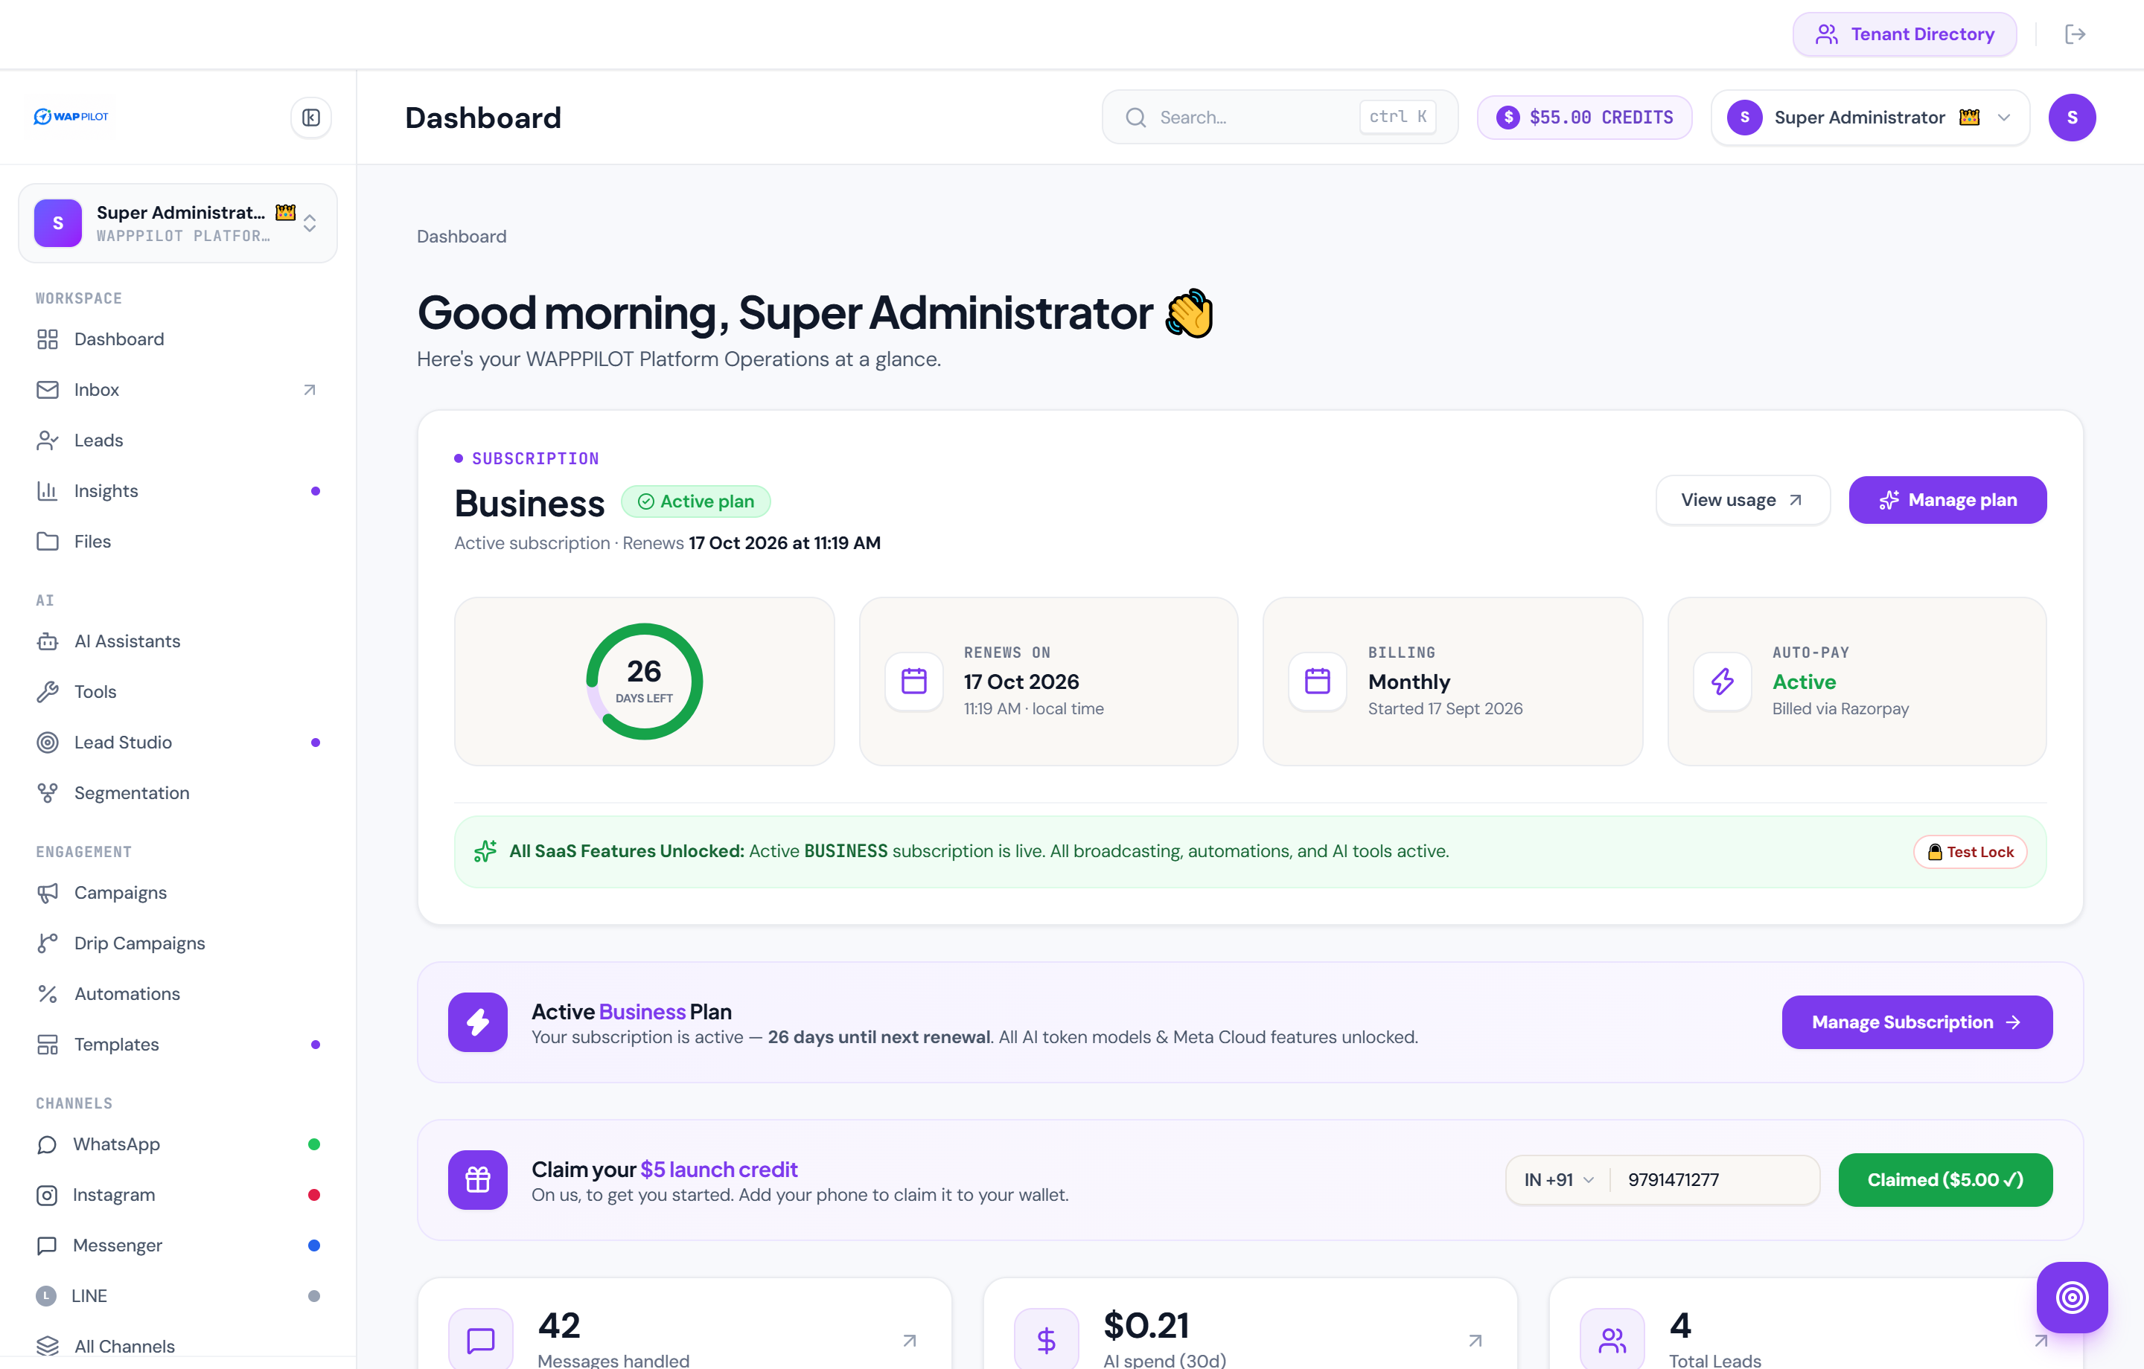
9. AI Business Studio: Autonomous 24/7 AI Concierge
Empower your WhatsApp Business with an intelligent generative AI agent trained specifically on your company's products, services, and policies.
- Customizable System Persona: Define your AI Concierge's identity, tone of voice, greeting messages, and domain expertise.
- Business Knowledge Base: Embed FAQs, pricing tables, operational hours, refund rules, and technical specifications.
- Creativity & Temperature Controls: Tune the AI agent's response variability for strict factual accuracy vs creative consultative sales conversations.
- Live Interactive Test Sandbox: Test real-time conversational responses in a simulated customer chat pane prior to deployment.
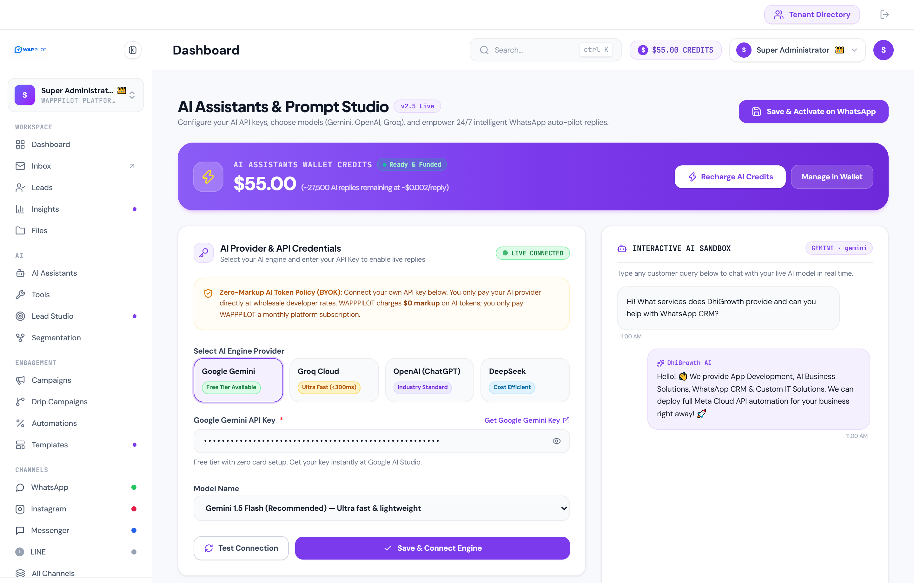
10. Super Admin Directory: Multi-Tenant Architecture & User Provisioning
Designed as a commercial SaaS product where administrators can provision independent tenant organizations and manage user accounts with strict database partitioning.
- New User & Tenant Provisioning: Admins create new tenant accounts with Full Name, Email, Username, Password, Role, and Company Name.
- Strict Data & Workspace Isolation: Each tenant user operates within an isolated workspaceId, ensuring templates, leads, automations, and chats remain strictly private.
- Granular Permission Matrix: Toggle specific feature access per tenant: WhatsApp Cloud API keys, Broadcasts, AI Studio, Team Inbox, Invoicing, and Lead Management.
- Direct Workspace Access URLs: Generates dedicated tenant onboarding and login URLs (e.g. ?tenant=company-slug) for branded customer access.
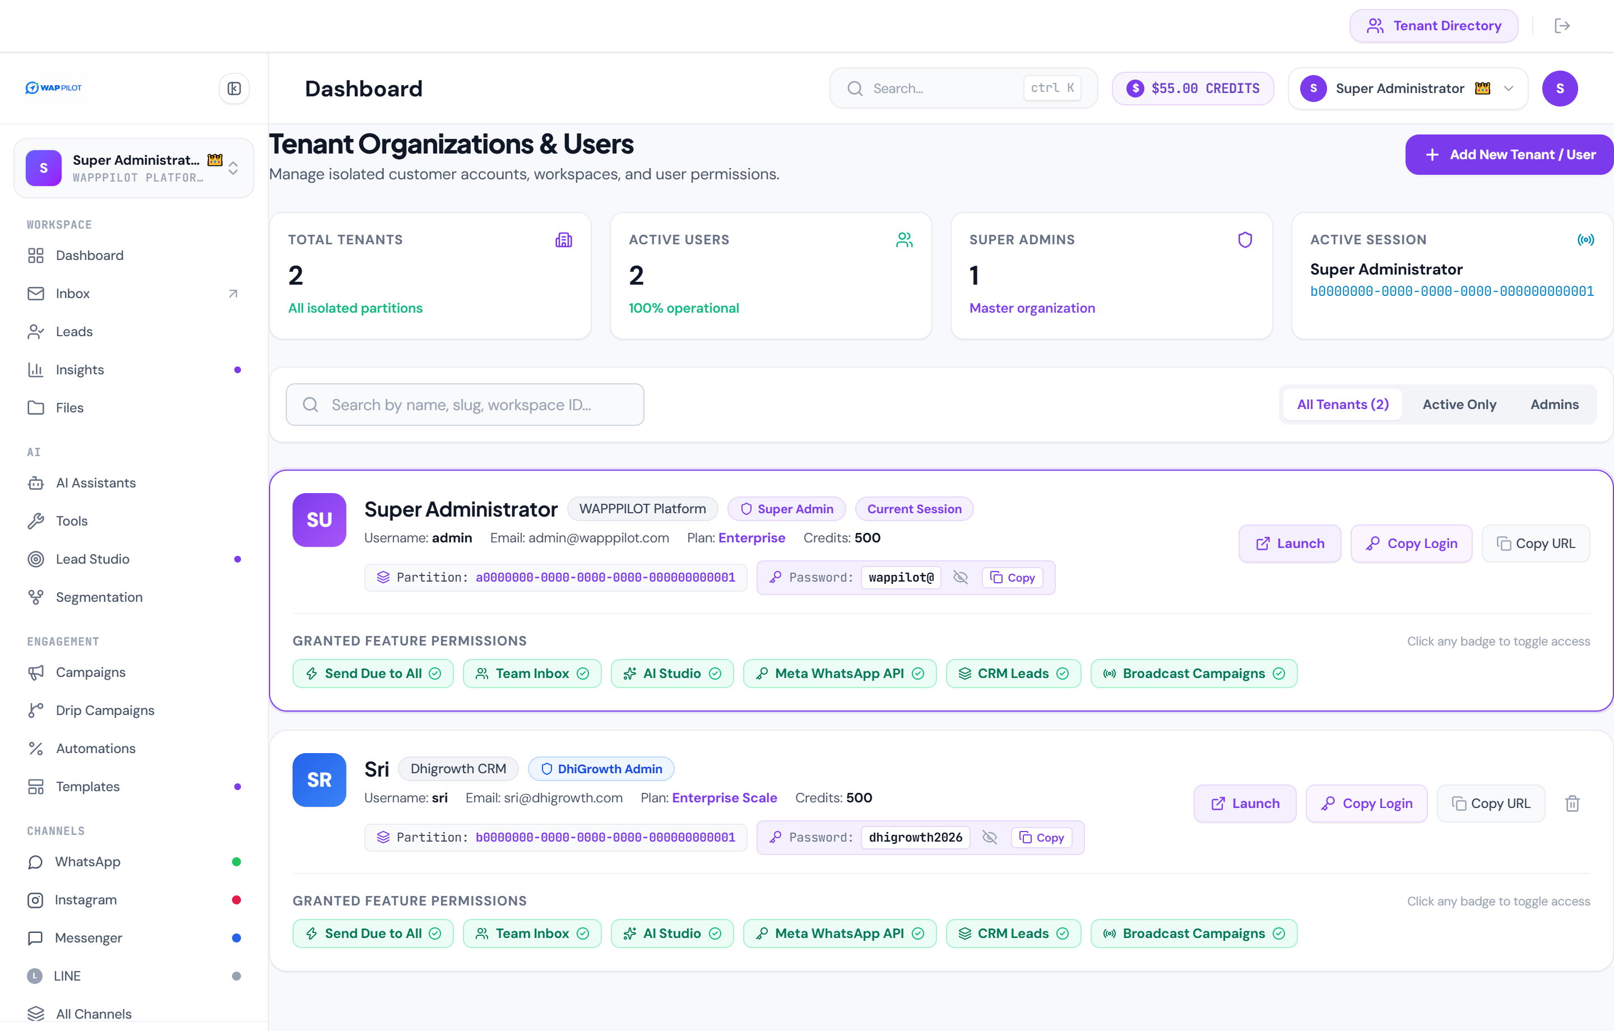
11. Omnichannel Hub & Official Meta WhatsApp Cloud API Setup
Connect and manage official Meta WhatsApp Business Accounts (WABA) alongside Instagram Direct, Facebook Messenger, and LINE in a unified gateway.
- Official Meta Cloud API Infrastructure: Input Phone Number ID, WABA ID, and permanent System User Access Tokens.
- 1-Click Meta Embedded Signup: Direct OAuth onboarding flow enabling clients to connect their WhatsApp Business phone number in under 60 seconds.
- Secure Webhook Gateway: Configured webhook endpoint (/webhook) with verify token handshakes ensuring verified, tamper-proof message ingestion.
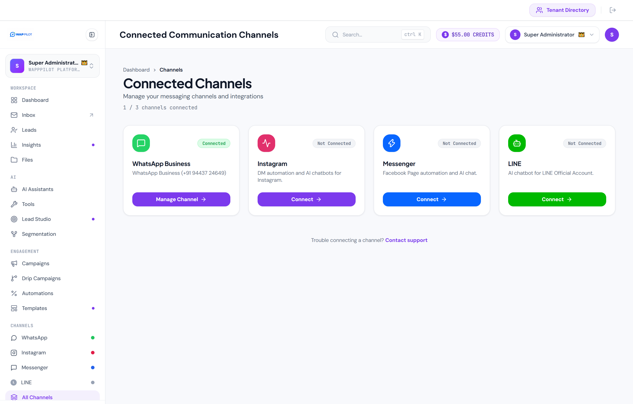
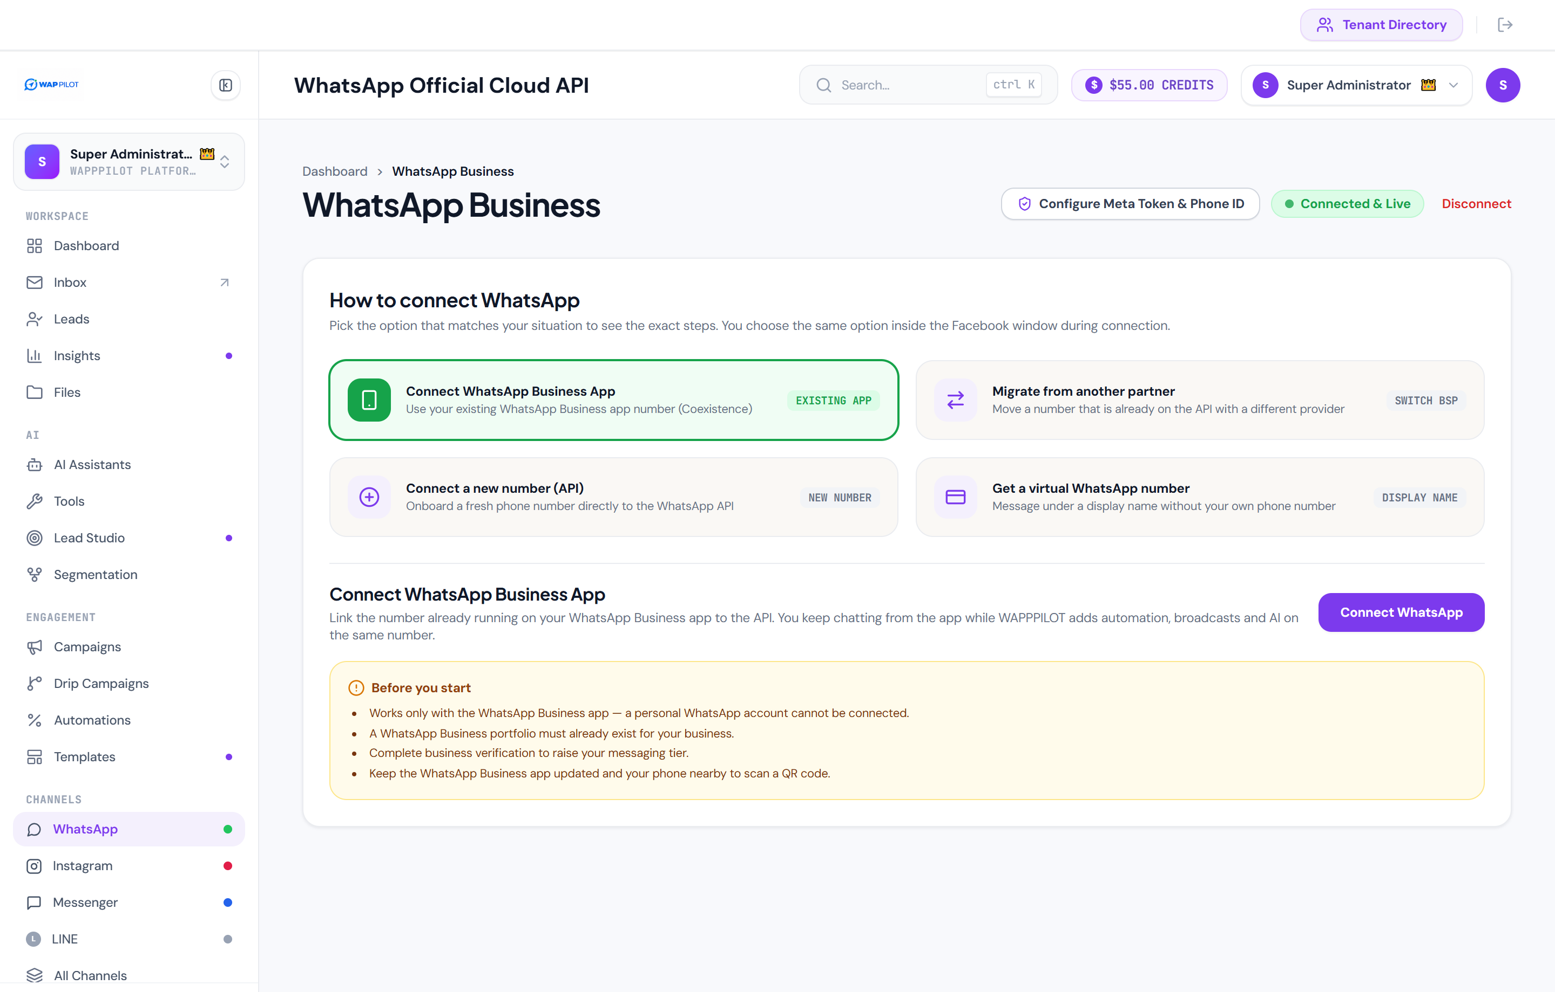
12. Wallet & Commercial SaaS Subscription Management
Transparent usage-based wallet accounting and flexible subscription plan tiers for enterprise operations.
- Dual-Currency Balance Tracking: Real-time wallet monitoring in USD ($) and Indian Rupees (₹).
- Instant Payment Gateway Top-Up: Recharge AI credits and template messaging balances via Razorpay or Stripe.
- Audit Trail & Transaction Logs: Complete records of top-up dates, payment IDs, gateways used, and balance adjustments.
- Commercial Tier Management: Support for Starter, Growth, and Enterprise subscription packages.
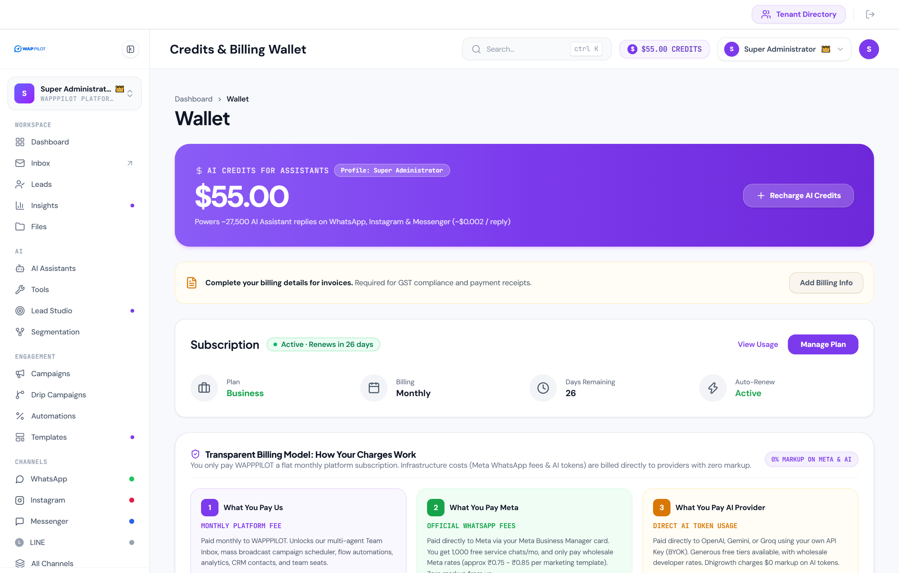
13. Commercial Readiness & Multi-Platform Availability
- Web & Cloud Architecture: Hosted on high-availability cloud infrastructure with 99.9% uptime SLA.
- Mobile Responsive UI: Fully optimized for desktop, tablet, and mobile browsers for on-the-go management.
- Enterprise Data Security: End-to-end encrypted WhatsApp communication, isolated tenant schemas, and bcrypt credential hashing.
- Official API Compliance: Strictly adheres to Meta WhatsApp Business Platform policies and rate limits.

